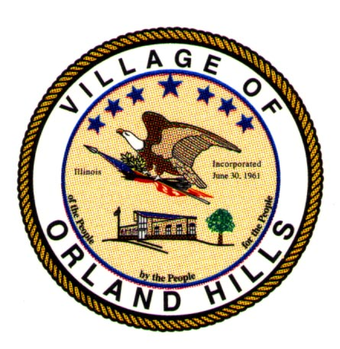
Village of Orland Hills
Proclamation # 2012-1002

Justin Ackmann Day

Whereas: Justin Ackmann is a resident of Orland Hills residing at 16836 S. Highview in the Village of Orland Hills; and

Whereas: Justin Ackmann attends Victor J. Andrew High School; and

Whereas: Justin Ackmann bowled a 109 at the State of Illinois Special Olympics competition on December 3, 2011 at Landmark lanes in Peoria, Illinois to bring home a gold medal; and

Whereas: Consolidated High School District # 230 has recognized Justin’s achievement for winning the state championship in the Special Olympics State Bowling Tournament; and

Whereas: according to his coach, Ms. Christy Mieling, Justin Ackmann has made huge improvements in his scores to capture the gold medal; and

Whereas: the Village of Orland Hills is proud to acknowledge the achievements of this fine young man and formally recognize his achievements for Orland Hills.

NOW, THEREFORE, I, Kyle R. Hastings, Village President of the Village of Orland Hills, do hereby proclaim today January 18, 2012 as Justin Ackmann Day in the Village of Orland Hills, Illinois.

IN WITNESS WHEREOF, I have hereunto set my hand and caused the Great Seal of the Village of Orland Hills to be affixed on this 18th day of January, 2012.

__________________
Kyle R. Hastings
(seal) Village President

Attest:

___________________
Mikki M. Burke
Village Clerk

