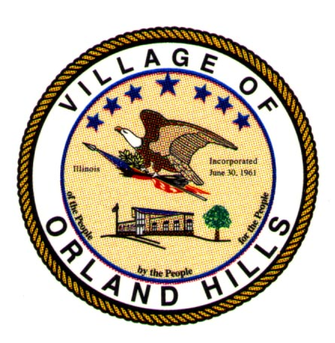 Proclamation # 2012-1001
Village of Orland Hills

Wolves Cheerleading Champions

Whereas: on November 19, 2011 all four Wolves Cheerleading Squads participated in a State of Illinois competition at Harper College in Palatine, Illinois and performed at a high level of precision and accuracy: and

Whereas: the Wolves Cheerleading Lights and Varsity squads both placed First by completing a tremendous performance: and

Whereas: the Wolves Cheerleading Lights and Varsity squads were honored by receiving a “bid” to perform at the State Competition in Hoffman Estates on December 3, 2011; and

Whereas: the Wolves Cheerleading Lights members are Alyssa Barragan, Kelsey Butler, Kaylee Butler, Lexi Cosich, Samantha Craig, Karlee DeKerf, Miranda DeVries, Caitlyn Drzyzga, Kaitlyn Fleming, Jessica Gibbs, Kiley Johnston, Madison LaSusa, Annie Marion, Lexi Murabito, Micki Orzech, Amy Rediger, Morgan Santiago , Bailee Savage, Emmily Scumaci, Makayla Torsan, Alyssa Villegas; and

Whereas: the Wolves Cheerleading Lights are coached by Karen Butler & Beth LaSusa; and

Whereas: the Wolves Cheerleading Junior Coaches are Abby Butler, Kate Blake, Tori Rolder, Taylor Rolder and Alyssa Papan; and

Whereas: the Wolves Cheerleading Varsity members are Angela Brann, Jessica Cuthbert, Hayley DeLarme, Madison DeRoo, Hannah Dieck, Sydney Fishback, Erika Ford, Kristina Gajda, Briana Gardner, Katie Golden, Gianni Iannantone, Alexis Marion, Jamie Markus, Isabella Mendiola, Jessica O'Connor, Danielle Pirsein, Stephanie Rivera, Kiley Rolder, Brandi Stroube, and Marissa Walls; and

Whereas: the Wolves Cheerleading Varsity Cheerleaders are coached by Shelly DeLarme, Shannon Dugetti, and Angelica Chakonas; and

Whereas: the Wolves Cheerleading Junior Varsity Cheerleaders are coached by Emily Powell and Kelsey Gasper; and

Whereas: Wolves Cheerleading is under the direction of Jen Iannantone; and

Whereas: the Village of Orland Hills is again proud to acknowledge the achievements of this fine, determined group of girls and coaches and formally recognizes their achievements for the Village of Orland Hills.

NOW, THEREFORE, I, Kyle R. Hastings, Village President of the Village of Orland Hills, do hereby proclaim January 22, 2012 through January 28, 2012, as

Wolves Cheerleading Week

IN WITNESS WHEREOF, I have hereunto set my hand and caused the Great Seal of the Village of Orland Hills to be affixed on this 18th day of January, 2012.

__________________
Kyle R. Hastings
Village President
(seal)

Attest:

___________________
Mikki M. Burke
Village Clerk

